Day 1 (05-03-26)
- Created an api contract and a OpenAPI documentation. You’ll find it in the project itself
- Created 2 spring boot services using spring boot initializer
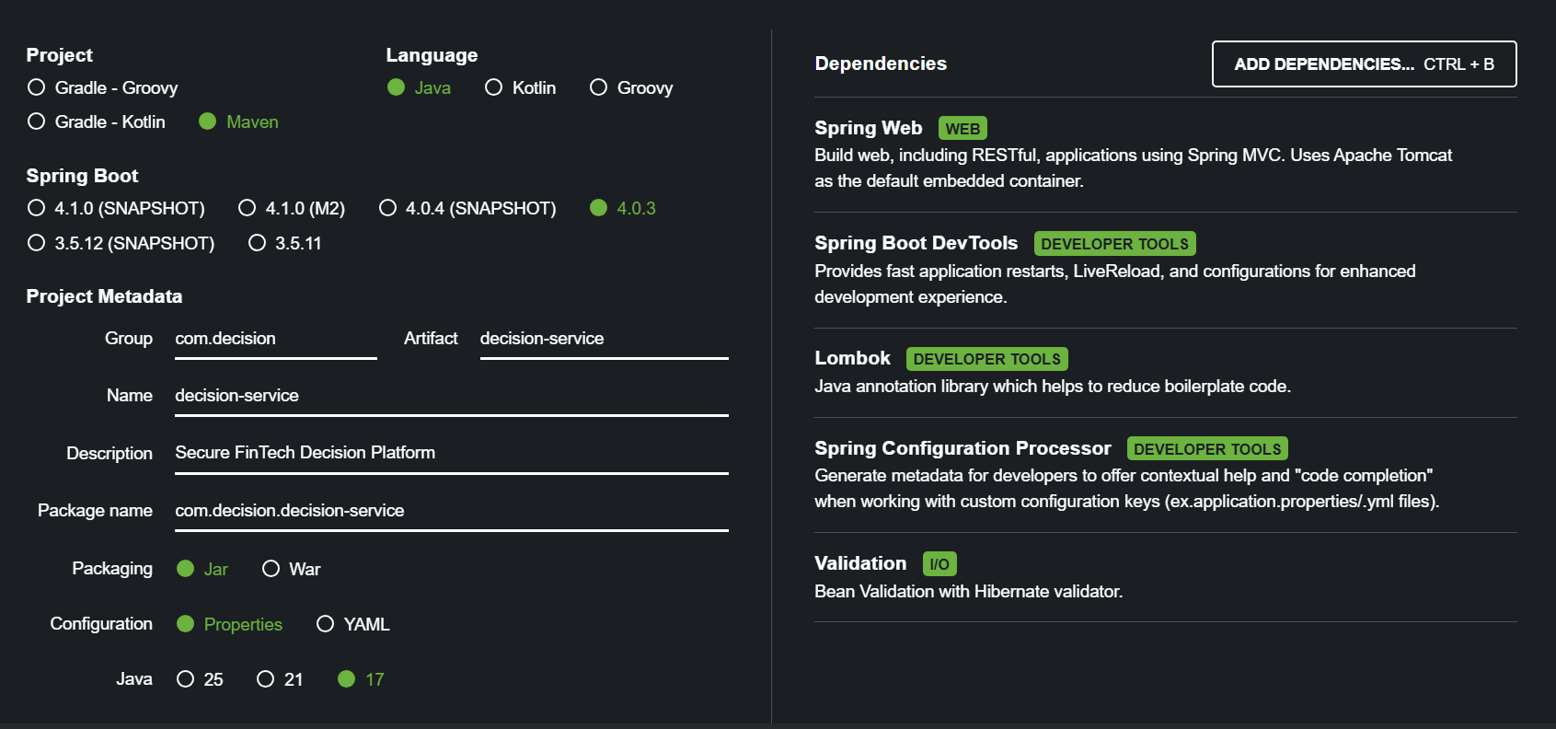
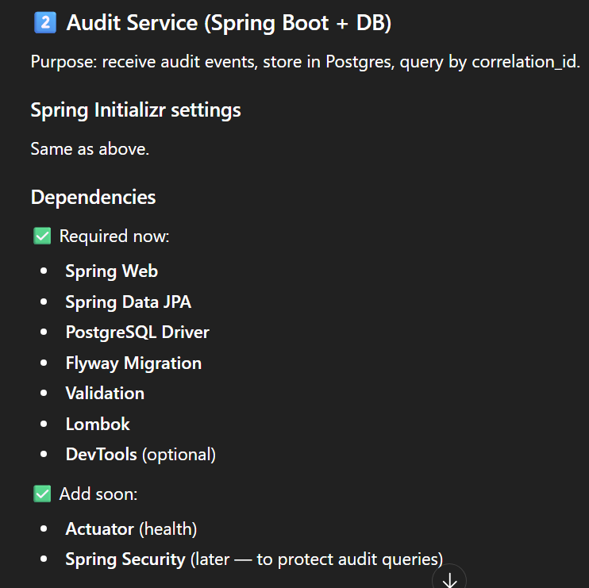
The reason why we are doing this is because each service is independent that makes our job easier to maintain them, dockerise them and they are independent of each other during any failures. There is another api for ML model but we’ll need fastAPI for this. Just focusing on these two for now

Setting up the github repo
- Created the new repo and in the folder location locally ran the following commands –
git init
git config --global user.email "anjanapriya.konapala6@gmail.com"
git remote add origin https://github.com/AnjanaPriya6/secure-fintech-decision-platform.git
git push -u origin develop
Will ask for authentication, authenticate

- Added the docs folder under the main project folder and added the OpenAPI documentation yaml. You can use this website to view the contract - https://editor.swagger.io in UI format
- Creating the basic folder structure under decision-service.
  - controller
  - model/dto/ LoginAttemptRequest, model/dto/responseDto
  - service
Added the following annotations to DecisionRequestDto:
@Data | Generates getters, setters, equals, hashCode, toString

@Builder | Allows builder pattern

@NoArgsConstructor | Required for Jackson deserialization

@AllArgsConstructor | Constructor with all fields
- Finished setting up the Dtos
- Added validations to the Dtos

Day 2 (25-03-26)

- Things I want to do for today –
  - Set up the DB
  - Figure out how the correlation IDs are created
  - Figure out how many tables we’d need
  - Write SPs if needed
Figuring out the right Database
This is important based on how we want to scale and one bad decision could lead to extended downtime later to shift to the right one, customer impact and data loss
Usually, database migration can take a very long time but the best we can do to manage with what we have right now is to change a few configuration steps. Like tuning the memory size, changing compaction and garbage collection management
For our project, we are choosing PostgreSQL for several reasons:
- Very good at handling transactional data
- Strong consistency
- Good at ACID properties
- Great for structured data (Which is what we have)
- Scalable
- Easy integration with spring boot
Databases are mainly of 3 categories
- RDBMS (uses SQL) – data is stored as tables and is structured
- NoSQL (non-relational) – flexible data storage. Sub-types are document DB (Stores in JSON, ex: MongoDB), Key-Value DB (key-value structure, used mostly for caching, sessions and rate limit, ex: redis), column DB (massive scaling, high write throughput, ex: Apache Cassandra), graph DB (stores relationships, fraud networks, ex: Neo4J)
- Time Series DB: used for logs, metrics and time-based data. Ex: Influx DB
So, we are obviously choosing RDBMS. Now the question is choosing the right type of RDBMS. Two broad categories
- Open-source:
- They are free
- Strong community support
- Flexible
- Ex: PostgreSQL, MariaDB, MySQL.
- Enterprise level:
- Paid, enterprise-grade support, hence used in banks and gov applications
- Ex: IBM DB2, Oracle, Microsoft SQL server
Notes: Figure out the number of tables we’d need, their data types, insert some dummy data, correlationIDs, how to see the DB values in postgresql, how to connect to springboot, insert a dummy record through api, eventually replace with sps if needed
Setting up the DB
We are using DBeaver because it’s free and great for PostgreSQL

Day3(07-04-26)
- Installed postgres and added to PATH in env variables.
- Created a new connection in DBeaver and gave in the right details and tested connection to success.
Day 4 (13-04-26)
- Took while to refine the design of the project and understand it better so coming back after a few days
- Created tables. Follow the DB setups doc
Day 5 (21-04-26)
Creating the Correlation ID
- We start with declaring the class as a Component using @Component so that it is indicated that this class is managed by Spring.
- We annotate the order to be 1. We need this to be the first to be executed even before the controller
- We use @SLF4J. For logs and also for MDC
- Import MDC - Mapped Diagnostic Context. This is SLF4J's mechanism for storing data that automatically gets attached to every log line written by the current thread
- We make sure that we are extending OncePerRequestFilter abstract class where we’ll use the doFilterinternal for our execution. It is a Spring base class that your filter extends. It guarantees that your filter logic runs exactly once per HTTP request — even in cases where a request is forwarded internally within your application. You extend this instead of implementing the raw Filter interface because the once-per-request guarantee is important.
- Inside the class, we declare three strings. These are more like look-ups.
- The header string - CORRELATION_ID_HEADER = "X-Correlation-Id" — this is the exact name of the HTTP header. When a caller sends X-Correlation-Id: some-value in their request, you read it using this constant. When you add the header to the response, you use this same constant.
- The MDC key string - CORRELATION_ID_MDC_KEY = "correlationId" — the key under which you store the correlation ID in MDC. This must exactly match what you put in logback-spring.xml — %X{correlationId}. If they do not match, the ID never appears in logs
- The Correlation ID prefix - GENERATED_ID_PREFIX = "c-" — when you generate a new correlation ID, you prefix it with "c-". This makes it easy to tell apart IDs generated by your system versus IDs provided by callers when looking at logs.
- Now we are implementing the doFilterInternal method from the OncePerRequestFilter abstract class. The inputs for this method are the HTTPRequest instance, HTTPResponse instance and FilterChain chain - the chain of remaining filters. After your filter does its work, it must call filterChain.doFilter() to pass control to the next filter and eventually to the controller. If you forget to call this, the request stops at your filter and the caller receives no response. This method throws ServletException, IOException
- Inside the method, we implemented a helper method that either creates the correlation ID if the user doesn’t provide it or assigns the user entered correalationID to the returning variable. Either way, after this line you have a correlation ID string ready to use
- We have started a try block just to make sure that we have something to fall back if anything goes wrong. Inside, we are storing a key-value pair in MDC. The key is already declared as a constant. We use the following line –
MDC.put(CORRELATION_ID_MDC_KEY, correlationId);
where correlationId is the output of the helper method that we called earlier. Example of a correlation ID - "c-7f3b5d2e-4a1c-4b8e-9d3f-1a2b3c4d5e6f".
- After this line, every single log statement written by any code running in the current thread - your controller, your services, your repositories, automatically includes correlationId=c-7f3b5d2e... in the log output. You do not pass it as a parameter. You do not reference it explicitly. MDC handles it invisibly.
- This works because MDC uses ThreadLocal internally. ThreadLocal means each thread has its own independent copy of the MDC map. Thread 1 handling request A has correlationId = c-aaa. Thread 2 handling request B has correlationId = c-bbb. They never interfere with each other.
- Later we set the same correlationId in the header that we’ll return to the user.
- After that, we have used a log that is only visible in debug mode. This way, SLF4J only builds the string if the log level is actually enabled. If DEBUG is disabled, no string is built at all - better performance
- Then we pass the request and response (with the new header we just built) to the next filters using FilterChain.doFilter() and eventually to the controller. This is mandatory. If you remove this line, the request stops at your filter. The controller never receives it. The caller waits forever or receives a blank response
- And in the finally block, we clear the MDC. This is very important. Because Spring Boot uses a thread pool. After your request completes, the thread that handled it does not die — it goes back into the pool and waits for the next request. If you do not clear MDC, the next request that runs on this thread inherits the previous request's correlation ID. Your logs become completely wrong — request B appears to have the correlation ID of request A.
- Then we define the helper method that we have used at the beginning of the method. First we check if the header isn’t null and then check if it’s not blank and in that case, we extract the correlationId or we generate it
- We generate a new correlation ID using UUID.randomUUID(). We append the prefix for a correlationID. We have a constant for this. Result would be similar to c-7f3b5d2e-4a1c-4b8e-9d3f-1a2b3c4d5e6f
Creating the logback file
- The format of this file is .xml
- Reads the spring.application.name property from your application.properties file and makes it available in this configuration as appName. You can use it in log patterns. If the property is not set, it defaults to "decision-service". Since it’s this service that we are declaring these properties in
- An appender is a destination for log output. This one sends logs to the console — your terminal. The name="CONSOLE" is just what you call it so you can reference it later.
- The pattern defines the format of every log line. Each % symbol is a placeholder:
- %d{HH:mm:ss.SSS} — the timestamp in hours:minutes:seconds.milliseconds format. Example: 14:23:45.123.
- [%thread] — the name of the thread processing this request. Example: [http-nio-8080-exec-1].
- %-5level — the log level left-aligned in a 5-character field. Example: INFO , DEBUG, ERROR.
- [%X{correlationId:-NO_CORRELATION_ID}] — reads correlationId from MDC. The :-NO_CORRELATION_ID part means "if correlationId is not in MDC, print NO_CORRELATION_ID instead of blank." This is the line that makes the correlation ID appear in every log message.
- %logger{36} — the name of the class that wrote the log, shortened to 36 characters. Example: c.f.d.filter.CorrelationIdFilter.
- %msg — the actual log message you wrote in your code.
- %n — a newline character. Each log entry ends here.
Creating CorrelationIdHolder
- This is how we can access the correlationId wherever we want in the code
- Declare the key as a constant (the same key that we declared in the filter. They should be the same or it doesn’t fetch the value. It is case-sensitive)
- We fall back to null if nothing is found. This is defensive, it should never return "UNKNOWN" in normal operation because the filter always sets the MDC value. But if somehow the code is called outside a request context, it degrades gracefully instead of throwing a NullPointerException
- A private constructor prevents anyone from creating an instance of this class with new CorrelationIdHolder(). Since all its methods are static, there is no reason to ever create an instance. Making the constructor private enforces that. This is a standard Java pattern for utility classes.
Final flow of CorrelationIdFilter
Request -> spring checks for filter and finds the CorrelationIdFilter.doFilterInternal() at Order(1) -> reads Id/generates one -> MDC.put() -> setting the ID in the response header-> pass control to FilterChain.doFilter() to execute other filters and eventually reach controller -> response built is forwarded to filterChain instance -> MDC.clear() keeps the thread fresh for next requests
Day 6 (23-04-26)
JWT Token Authorization
- Added the necessary dependencies to the pom.xml file and reloaded maven (jjwt-api, jjwt-impl, jjwt-jackson. Why three JJWT artifacts? The library separates its API from its implementation deliberately. You code against the API — the interfaces — and the implementation is swapped in at runtime. This is a standard Java pattern. You never need to import from jjwt-impl or jjwt-jackson directly.)
- Create JWTUtil class in the Util package. Annotate with @Component. Other classes can @Autowired inject
- Read secret and expiration dates from the application-local.properties file using @Value(“${jwt.secret}”) as String and long
- Then we convert the secret into byte array and feed it to encrypt via HMAC-SHA that returns a SecretKey object
byte[] keyBytes = secret.getBytes(StandardCharsets.UTF_8);
return Keys.hmacShaKeyFor(keyBytes); (returns a SecretKey object)
- JJWT automatically selects HMAC-SHA256 or HMAC-SHA512 depending on key length. With 32 bytes it selects HS256. JJWT throws WeakKeyException here if your key is too short — this is the safety check.
- Now we create a new method to create a token. We return the Jwts String (xxx.yyy.zzz format for jwt) built with subject, issuedAt date, expiration date (issuedAt + expiration milliseconds stated in application-local.properties, signWith with the SecretKey generated from the previous step and finish it with compact() this ensure that the object is returned as a String, in the format we wanted.
- Now we write a method to see if the token received is valid. For this, we need a method that parses the claims. We have parseClaims for that and using JWT.parser(), we verify against the signedKey and get the payload and return it. We throw appropriate errors when the parsing fails
- Now we create the JwtFilter file. We annotate it with @RequiredArgsConstructor that generates a constructor that takes all the final fields as parameters, @Order(2) because we want this to run after the CorrelationIDFilter
- We have two final strings - AUTHORIZATION_HEADER — the standard HTTP header name for authentication. The HTTP specification defines this. BEARER_PREFIX — JWT tokens are sent as Bearer tokens. The full header value looks like Bearer eyJhbGciOiJIUzI1NiJ9.... You need to strip "Bearer " (note the space) before parsing the token string.
- Later - private final JwtUtil jwtUtil;
private final — final because it will never be reassigned after construction. JwtUtil is injected by Spring through the constructor that @RequiredArgsConstructor generates. You never call new JwtUtil() — Spring manages the lifecycle.
- We override the doFilterInternal() like we have seen before for the correlationIDFilter
- Then we get the authHeader from the request and return null if not present (we don’t need authentication for two endpoints. We handle them like this.
- authHeader == null — no Authorization header present. Could be a legitimate request to an unauthenticated endpoint like /v1/health, or a missing token.
- !authHeader.startsWith(BEARER_PREFIX) — header exists but does not start with "Bearer ". Could be a Basic auth header or a malformed request. Either way, not our concern here.
- If either condition is true — pass the request along without setting authentication. Spring Security's configuration (SecurityConfig) will then determine whether the endpoint requires authentication. If it does and there is no authentication in the SecurityContext, Spring Security returns 401 automatically. If the endpoint is public (/v1/health), the request proceeds normally.
- substring(BEARER_PREFIX.length()) — strips the "Bearer " prefix (7 characters) from the header value, leaving just the JWT string
- Check the validity and return an appropriate message if it’s wrong.
- The message is generated via a custom method called sendUnauthorizedResponse()where we first set the status to unauthorized, set the content-type and character-encoding. We attach the response with correlationID, timestamp and the message as string and we use responseBody.writer() to write the JSON string directly to the HTTP response body. getWriter() returns a PrintWriter for writing character data to the response.
- Why write the response directly instead of returning an ErrorResponse object? At the filter level, you are not inside a Spring MVC controller. You do not have the luxury of returning an object and letting Spring serialise it. You must write raw HTTP directly. This is why you build the JSON string manually here.
- Now creating SecurityConfig file.
- Annotate with @Configuration — tells Spring this class contains bean definitions. Spring processes it at startup. @EnableWebSecurity — activates Spring Security's web security features. Without this, Spring Security would not process HTTP requests at all and @RequiredArgsConstructor
- Using private final JwtAuthenticationFilter jwtAuthenticationFilter;
Spring passes it in through the constructor that @RequiredArgsConstructor generates and is injected.
@Bean
public SecurityFilterChain securityFilterChain(HttpSecurity http) throws Exception {}
@Bean — the return value of this method is registered as a Spring bean. Spring Security uses this SecurityFilterChain to process every HTTP request.
HttpSecurity http — the fluent builder for Spring Security configuration. Spring injects it automatically.
- http.csrf(AbstractHttpConfigurer::disable) — disables CSRF protection.
Why? CSRF protection is designed for browser-based applications that use cookies for authentication. Your API uses JWT in Authorization headers — not cookies. CSRF attacks cannot exploit Authorization header based authentication because a browser cannot add custom headers in cross-origin requests without CORS allowing it. Enabling CSRF on a stateless REST API would break your clients for no security benefit.
- SessionCreationPolicy.STATELESS — tells Spring Security never to create or use HTTP sessions. Every request must be independently authenticated via JWT. There is no "logged in" session state on the server. Why stateless? This is what makes JWT suitable for distributed systems. Any instance of your service can verify any token using the same secret key. No shared session store needed. Requests can go to any server instance behind a load balancer.
- .authorizeHttpRequests() — configures which endpoints require authentication.
- .requestMatchers("/v1/health").permitAll() — anyone can call GET /v1/health without a token. Monitoring systems call this. They cannot obtain JWT tokens.
- .requestMatchers("/auth/token").permitAll() — anyone can call POST /auth/token without a token. This is how clients get a token in the first place. If this required a token, nobody could ever authenticate.
- .anyRequest().authenticated() — every other endpoint requires a valid JWT. If a request reaches any other path without authentication in the SecurityContext, Spring Security returns 401 automatically.
- Order matters here. Spring Security evaluates rules top to bottom and stops at the first match. /v1/health and /auth/token are matched first and permitted. Everything else hits anyRequest() last.
- .addFilterBefore() — inserts your JwtAuthenticationFilter before Spring Security's default UsernamePasswordAuthenticationFilter in the filter chain.
- UsernamePasswordAuthenticationFilter.class — the position marker. You are saying "run my filter before this one."
- Why before this specific filter? UsernamePasswordAuthenticationFilter is where Spring Security normally handles form-based authentication. By inserting before it, your JWT authentication runs first and populates the SecurityContext before Spring Security's own filters try to check authentication. This is the standard pattern for JWT in Spring Security.
- Now we create AuthController
- Inject client_ID and client_Secret from application-local.properties. Why not hardcode them in the controller? If hardcoded, every developer who reads the source code knows the credentials. Reading from properties means they can be different per environment and kept out of version control in production.
- @PostMapping("/token") — maps HTTP POST /auth/token to this method.
- ResponseEntity<?> — allows returning different response types and HTTP status codes. The ? wildcard means the body type can be anything — either a success response map or an error response map.
- @RequestBody Map<String, String> request — deserialises the JSON request body into a map. For a body like {"client_id": "test-client-01", "client_secret": "test-secret-01"} you get a map with keys "client_id" and "client_secret".
- Why Map instead of a DTO? For a test-only endpoint with two fields, a full DTO class is unnecessary overhead. A map is simpler and clear enough.
- Read the client ID and secret in the request and validate credentials. If either is null (not provided) or does not match the configured test credentials, return 401.
- ResponseEntity.status(401).body(...) — builds a 401 response with a JSON body. Map.of() creates an immutable map with the given key-value pairs.
- jwtUtil.generateToken(clientId) — generates a signed JWT with clientId as the subject.
- ResponseEntity.ok() — returns 200 with the given body.
- Map.of("access_token", token, "token_type", "Bearer", "expires_in", 3600) — the response body. The client stores access_token and sends it as Authorization: Bearer {access_token} on every subsequent request.
- "expires_in", 3600 — tells the client the token expires in 3600 seconds (1 hour). The client uses this to know when to request a new token. This is informational — the actual expiration is enforced by JJWT when parsing.

Day 7 (28th Apr)
GlobalExceptionHandler
- GlobalExceptionHandler intercepts every exception before Spring touches it and converts it into your standard ErrorResponse structure.
- Annotate the class with this - @RestControllerAdvice — tells Spring this class intercepts exceptions thrown by any controller in your application. Combines @ControllerAdvice and @ResponseBody — meaning every method in this class automatically serialises its return value to JSON.
- Added three exceptions – MethodArgumentNotValid, Exception, custom exception class ResourceNotFoundException

Day 8(13-5-26)
- Added another exception – HttpMessageNotReadableException for malformed Json

Day 9
Added the policyConfig, policyConfigRepo, all enums required for decisionAudit
Day 10
Added decisionAudit entity and the repo

